Online Auction Registration Guide

- Go to the link in your email, which will take you to the main bidding page.
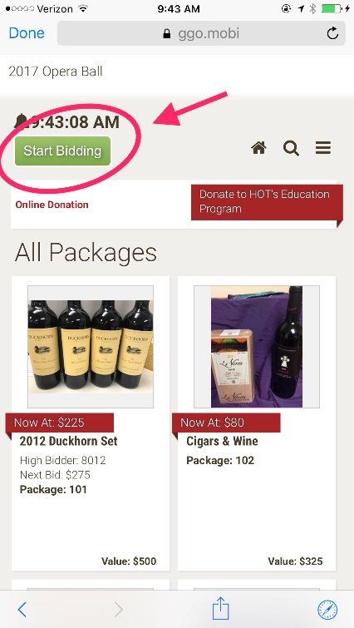
Click the Box “Start Bidding”

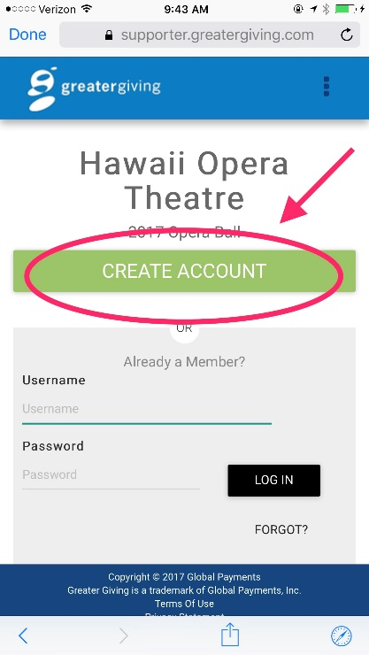
- Click on “Create Account”

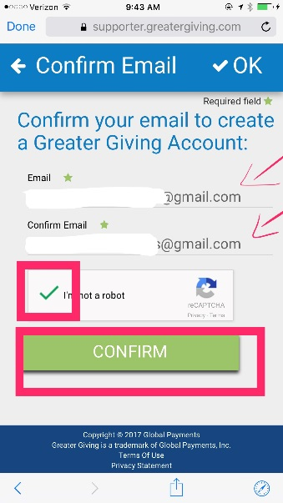
- Enter your email address twice, then check the “I am not a robot” box, then click “Confirm”

- Next you will see this screen:
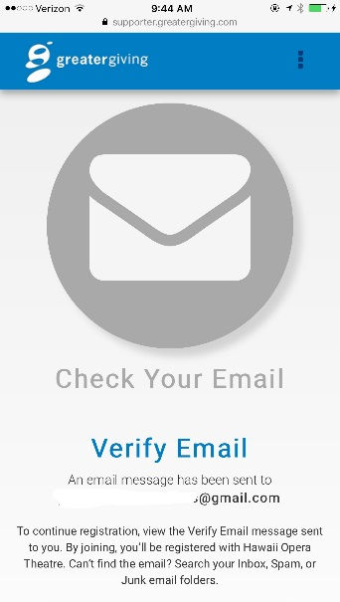
You will have to exit the page and check your email.

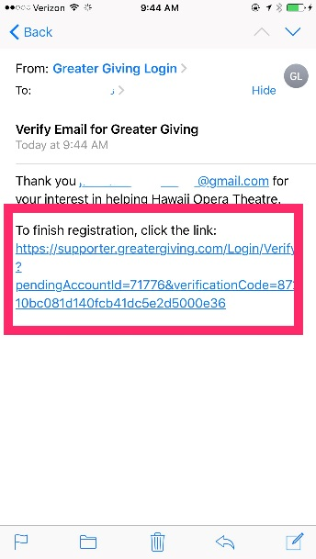
- You should receive an email from Greater Giving, if you don’t see one within a few moments check your spam. Once you open it click this link:

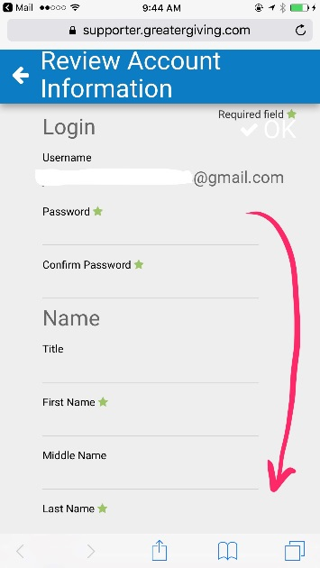
- Next you will see a long page to enter all of your account information; you create a password, enter your name, address, phone number, and credit card information:

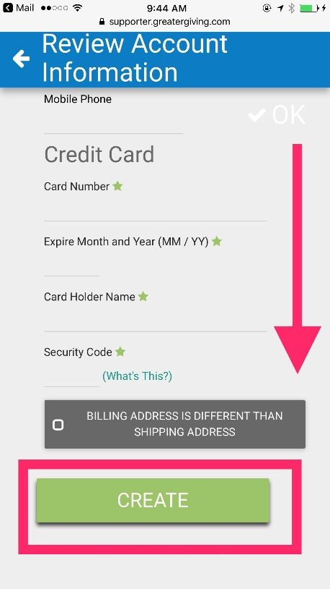
- After entering all of your information click “Create”

And you’re all set to start bidding!
Thank you!
- Hawaii Opera Theatre

